7 Self Generating Maze

Saving Your Project
Before jumping into this section here, you may want to save your project somewhere into a specifically named back up folder. We want to do this because at this point, we have a perfectly good working game. And this tutorial will be diving into some code — in face, it will be diving into a lot of code. We want our maze to automatically self- generate when the hero enters the room. This will mean, we will not need to mess with trying to come up with our own ideas for mazes or mess with those map overlays or anything. This means that our game will simply randomly create its own mazes. This is a fascinating idea, but it is also very code intensive. So, if you would like to follow along with this tutorial (please back up your game) then come join me because we are about to tread into some very murky waters here.

Scripts, what are they?
Scripts is sort of like the GML code that you placed into the hero object to make him move, and change sprites based on the direction that our hero guy is moving in, except that scripts have no object attached to it. It is pure code. You place these script files into a folder in your Asset Browser, named Scripts. But, as you have learned in an earlier tutorial, and with the latest updates of Game Maker, it is no longer provided for us. So, we will have to create a folder in the Asset Browser and name it Scripts. If you have not already created this folder in your game, you will want to create it now.
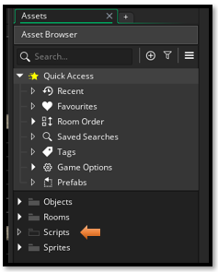

Create the Script Files
Now inside of the Script file, we want to right click and create a few Scripts. In fact, we will want to create 4 Scripts. We will just create the scripts now and name them. Then I will show you the code that you want to go into them.
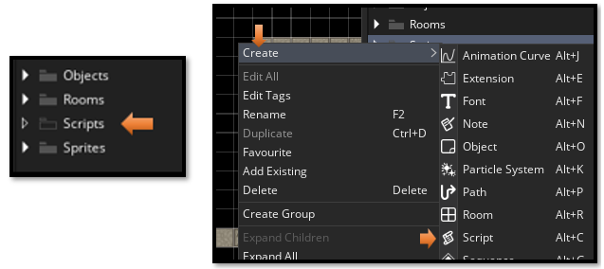

Again, you want to choose The GML Code Method for writing code.
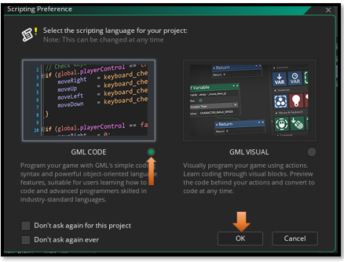
Name Your Scripts like this:
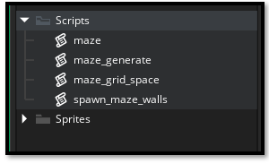

Start Writing Your Scripts
You will want to copy and paste all of your code into the different script files in your game. You can read through the comments in green to see what each part of this code is doing. Do not think that we are ready to test our game after writing these scripts. We will need to also make a controller object, which can be thrown into the room. and write some more code for the hero.
Since this code will be creating the hero, and door for us, we also will be removing both of these objects from the room. Along with all of your wall objects used for the inner maze. This code will be creating our maze for us. We just want the outer walls to be in the room, and that is it.

//Scripts

~~~~~~~~~~~~~~~~~~~~~~~~~~ MAZE ~~~~~~~~~~~~~~~~~~~~~~~~~~~~~~~~
function maze(_style, _width, _height) constructor {
style = _style;
w = _width;
h = _height;
// Start and end at interior cells (not on boundary)
startPoint = [1, 1];
endPoint = [w - 2, h - 2];

grid = [];
for (var i = 0; i < w; i++) {
grid[i] = [];
for (var j = 0; j < h; j++) {
grid[i][j] = new maze_grid_space();
}
}

// IMPORTANT: Pre-carve an opening from the boundary into the start cell
// This ensures the hero at [1,1] has a path carved TO it
// Open the wall between [0,1] and [1,1]
grid[0][1].right = false;
}

~~~~~~~~~~~~~~~~~~~~~~~~~~~~MAZE_GENERATE~~~~~~~~~~~~~~~~~~~~~~~~~~~~~~~~
function maze_generate(_mazeStruct) {
var branches = ds_stack_create();
var g = _mazeStruct.grid;

var cp = [_mazeStruct.startPoint[0], _mazeStruct.startPoint[1]];
g[cp[0]][cp[1]].visited = true;
ds_stack_push(branches, cp);

while (!ds_stack_empty(branches)) {
cp = ds_stack_top(branches);

var pdir = ds_list_create();
if (cp[0] > 0 && !g[cp[0] - 1][cp[1]].visited) ds_list_add(pdir, [cp[0] - 1, cp[1]]);
if (cp[0] < _mazeStruct.w - 1 && !g[cp[0] + 1][cp[1]].visited) ds_list_add(pdir, [cp[0] + 1, cp[1]]);
if (cp[1] > 0 && !g[cp[0]][cp[1] - 1].visited) ds_list_add(pdir, [cp[0], cp[1] - 1]);
if (cp[1] < _mazeStruct.h - 1 && !g[cp[0]][cp[1] + 1].visited) ds_list_add(pdir, [cp[0], cp[1] + 1]);

if (ds_list_size(pdir) == 0) {
ds_stack_pop(branches);
} else {
ds_list_shuffle(pdir);
var np = pdir[| 0];

g[np[0]][np[1]].visited = true;
ds_stack_push(branches, np);

if (np[0] > cp[0]) g[cp[0]][cp[1]].right = false;
if (np[0] < cp[0]) g[np[0]][np[1]].right = false;
if (np[1] > cp[1]) g[cp[0]][cp[1]].down = false;
if (np[1] < cp[1]) g[np[0]][np[1]].down = false;
}

ds_list_destroy(pdir);
}

ds_stack_destroy(branches);
}

//~~~~~~~~~~~~~~~~~~~MAZE GRID SPACE~~~~~~~~~~~~~~~~~~~~~~

function maze_grid_space() constructor {
visited = false;
right = true;
down = true;
}

//~~~~~~~~~~~~~~~~~~~SCRIPT SPAWN MAZE WALLS~~~~~~~~~~~~~~~~~~~~~~

//spawn_maze_walls (GRID-BASED MAZE WALLS)
// This function creates walls on a proper grid where:
// - Each cell is _cellSize x _cellSize pixels
// - Walls are placed at the edges between cells
// - The maze algorithm's right/down properties indicate walls between adjacent cells

function spawn_maze_walls(_mazeStruct, _cellSize, _xOffset, _yOffset) {
var m = _mazeStruct;
var s = _cellSize;
var xx = _xOffset;
var yy = _yOffset;

// Calculate wall sprite size (assuming 32x32 wall tiles)
var wall_size = 32;
var walls_per_cell = s / wall_size; // How many wall tiles fit per cell edge

show_debug_message("=== BUILDING GRID-BASED MAZE WALLS ===");
show_debug_message("Maze size: " + string(m.w) + " x " + string(m.h) + " cells");
show_debug_message("Cell size: " + string(s) + "px, Wall tile size: " + string(wall_size) + "px");
show_debug_message("Walls per cell edge: " + string(walls_per_cell));

// Track placed walls to prevent duplicates
var placed_walls = ds_map_create();

// Create interior maze walls based on the maze algorithm
for (var i = 0; i < m.w; i++) {
for (var j = 0; j < m.h; j++) {
// Calculate the TOP-LEFT corner of this cell in pixels
var cell_left = xx + i * s;
var cell_top = yy + j * s;

// RIGHT WALL - Wall between cell [i,j] and cell [i+1,j]
// Only place if NOT at the rightmost column AND the maze says there's a wall
if (i < m.w - 1 && m.grid[i][j].right == true) {
// Wall goes along the right edge of this cell
var wall_x = cell_left + s; // Right edge of cell

// Place wall tiles along the full height of the cell edge
for (var tile = 0; tile < walls_per_cell; tile++) {
var wall_y = cell_top + tile * wall_size;

// Create unique key to prevent duplicate walls
var wall_key = string(wall_x) + "_" + string(wall_y);

if (!ds_map_exists(placed_walls, wall_key)) {
// Check if this position would collide with door
if (!position_meeting(wall_x, wall_y, obj_door)) {
instance_create_layer(wall_x, wall_y, "Walls", obj_wall_plain);
ds_map_add(placed_walls, wall_key, true);
}
}
}
}

// DOWN WALL - Wall between cell [i,j] and cell [i,j+1]
// Only place if NOT at the bottom row AND the maze says there's a wall
if (j < m.h - 1 && m.grid[i][j].down == true) {
// Wall goes along the bottom edge of this cell
var wall_y = cell_top + s; // Bottom edge of cell

// Place wall tiles along the full width of the cell edge
for (var tile = 0; tile < walls_per_cell; tile++) {
var wall_x = cell_left + tile * wall_size;

// Create unique key to prevent duplicate walls
var wall_key = string(wall_x) + "_" + string(wall_y);

if (!ds_map_exists(placed_walls, wall_key)) {
// Check if this position would collide with door
if (!position_meeting(wall_x, wall_y, obj_door)) {
instance_create_layer(wall_x, wall_y, "Walls", obj_wall_plain);
ds_map_add(placed_walls, wall_key, true);
}
}
}
}
}
}

var total_walls = ds_map_size(placed_walls);
ds_map_destroy(placed_walls);

show_debug_message("Maze walls created: " + string(total_walls) + " wall tiles placed");
show_debug_message("=== MAZE WALL GENERATION COMPLETE ===");
}

Creating the Controller Object
If you have not already created your controller object inside of the Asset Browser, now is the time to create it.
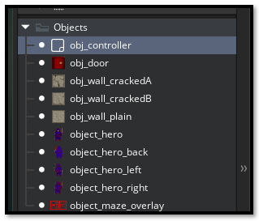

Code for the Controller Object
Inside of the Create Event
We want to create a Create Event for this controller, so that we can write some code inside of it. Add Event and then select Create from the Menu. The Controller object will be invisible inside of the room, so it will not be using a sprite at all.
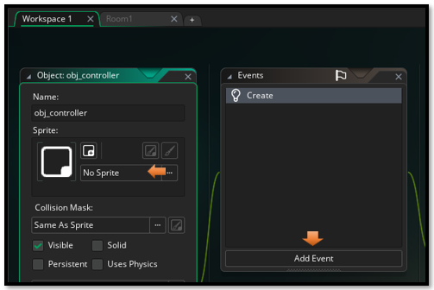

//spawn_maze_walls (GRID-BASED MAZE WALLS)
// This function creates walls on a proper grid where:
// - Each cell is _cellSize x _cellSize pixels
// - Walls are placed at the edges between cells
// - The maze algorithm's right/down properties indicate walls between adjacent cells

function spawn_maze_walls(_mazeStruct, _cellSize, _xOffset, _yOffset) {
var m = _mazeStruct;
var s = _cellSize;
var xx = _xOffset;
var yy = _yOffset;

// Calculate wall sprite size (assuming 64x64 wall tiles)
var wall_size = 64;
var walls_per_cell = s / wall_size; // How many wall tiles fit per cell edge

show_debug_message("=== BUILDING GRID-BASED MAZE WALLS ===");
show_debug_message("Maze size: " + string(m.w) + " x " + string(m.h) + " cells");
show_debug_message("Cell size: " + string(s) + "px, Wall tile size: " + string(wall_size) + "px");
show_debug_message("Walls per cell edge: " + string(walls_per_cell));

// Track placed walls to prevent duplicates
var placed_walls = ds_map_create();

// Create interior maze walls based on the maze algorithm
for (var i = 0; i < m.w; i++) {
for (var j = 0; j < m.h; j++) {
// Calculate the TOP-LEFT corner of this cell in pixels
var cell_left = xx + i * s;
var cell_top = yy + j * s;

// RIGHT WALL - Wall between cell [i,j] and cell [i+1,j]
// Only place if NOT at the rightmost column AND the maze says there's a wall
if (i < m.w - 1 && m.grid[i][j].right == true) {
// Wall goes along the right edge of this cell
var wall_x = cell_left + s; // Right edge of cell

// Place wall tiles along the full height of the cell edge
for (var tile = 0; tile < walls_per_cell; tile++) {
var wall_y = cell_top + tile * wall_size;

// Create unique key to prevent duplicate walls
var wall_key = string(wall_x) + "_" + string(wall_y);

if (!ds_map_exists(placed_walls, wall_key)) {
// Check if this position would collide with door
if (!position_meeting(wall_x, wall_y, obj_door)) {
instance_create_layer(wall_x, wall_y, "Walls", obj_wall_plain);
ds_map_add(placed_walls, wall_key, true);
}
}
}
}

// DOWN WALL - Wall between cell [i,j] and cell [i,j+1]
// Only place if NOT at the bottom row AND the maze says there's a wall
if (j < m.h - 1 && m.grid[i][j].down == true) {
// Wall goes along the bottom edge of this cell
var wall_y = cell_top + s; // Bottom edge of cell

// Place wall tiles along the full width of the cell edge
for (var tile = 0; tile < walls_per_cell; tile++) {
var wall_x = cell_left + tile * wall_size;

// Create unique key to prevent duplicate walls
var wall_key = string(wall_x) + "_" + string(wall_y);

if (!ds_map_exists(placed_walls, wall_key)) {
// Check if this position would collide with door
if (!position_meeting(wall_x, wall_y, obj_door)) {
instance_create_layer(wall_x, wall_y, "Walls", obj_wall_plain);
ds_map_add(placed_walls, wall_key, true);
}
}
}
}
}
}

var total_walls = ds_map_size(placed_walls);
ds_map_destroy(placed_walls);

show_debug_message("Maze walls created: " + string(total_walls) + " wall tiles placed");
show_debug_message("=== MAZE WALL GENERATION COMPLETE ===");

Hero Create Event
We will be adding another event to the hero. This time it will be the create event. It will be used for creating or spawning the hero and door object automatically for us when we enter the maze.
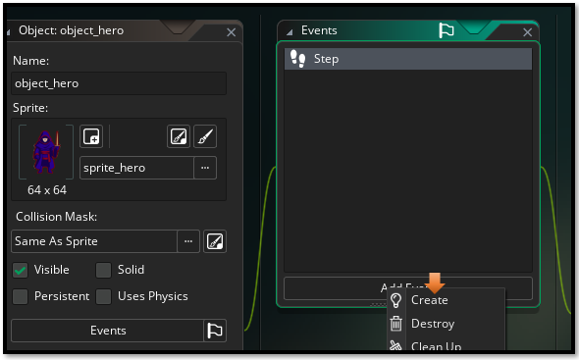

persistent = true;

//Create Event
// Hero startup - check for wall conflicts
show_debug_message("=== HERO STARTUP CHECK ===");
show_debug_message("Hero spawned at: (" + string(x) + ", " + string(y) + ")");

// Check if any walls exist at hero position
var wall_at_position = instance_position(x, y, obj_wall_plain);
if (wall_at_position != noone) {
show_debug_message("WARNING: Wall found at hero position!");
show_debug_message("Wall ID: " + string(wall_at_position));
}

// Check area around hero for walls
var walls_nearby = collision_rectangle(x - 32, y - 32, x + 32, y + 32, obj_wall_plain, false, true);

// TYPE CHECK: Verify we got a ds_list (similar to your isinstance check)
show_debug_message("Type check - walls_nearby type: " + string(typeof(walls_nearby)));
if (walls_nearby == noone) {
show_debug_message("No collision result (noone returned)");
} else if (!ds_exists(walls_nearby, ds_type_list)) {
show_debug_message("ERROR: Expected ds_list but got different type!");
show_debug_message("Actual type: " + string(typeof(walls_nearby)));
// Handle non-list result - could be a single instance
if (instance_exists(walls_nearby)) {
show_debug_message("Got single wall instance instead of list");
show_debug_message(" Wall at (" + string(walls_nearby.x) + ", " + string(walls_nearby.y) + ")");
}
} else {
// We have a valid ds_list - safe to use ds_list functions
if (ds_list_size(walls_nearby) > 0) {
show_debug_message("Walls found near hero position:");
for (var i = 0; i < ds_list_size(walls_nearby); i++) {
var wall_inst = walls_nearby[| i];
show_debug_message(" Wall " + string(i) + " at (" + string(wall_inst.x) + ", " + string(wall_inst.y) + ")");
}
} else {
show_debug_message("ds_list exists but is empty");
}
// Always destroy the ds_list to prevent memory leaks
ds_list_destroy(walls_nearby);
}

show_debug_message("=== HERO CHECK COMPLETE ===");

//Step Event
// --- Movement Input ---
var move_x = keyboard_check(vk_right) - keyboard_check(vk_left);
var move_y = keyboard_check(vk_down) - keyboard_check(vk_up);

var spd = 4;
var dx = move_x * spd;
var dy = move_y * spd;

// --- Collision Check ---
if (dx != 0 || dy != 0) {
// Check full diagonal move
if (!place_meeting(x + dx, y + dy, obj_wall_plain) &&
!place_meeting(x + dx, y + dy, obj_wall_crackedA) &&
!place_meeting(x + dx, y + dy, obj_wall_crackedB)) {
x += dx;
y += dy;
} else {
// Try horizontal only
if (!place_meeting(x + dx, y, obj_wall_plain) &&
!place_meeting(x + dx, y, obj_wall_crackedA) &&
!place_meeting(x + dx, y, obj_wall_crackedB)) {
x += dx;
}

// Try vertical only
if (!place_meeting(x, y + dy, obj_wall_plain) &&
!place_meeting(x, y + dy, obj_wall_crackedA) &&
!place_meeting(x, y + dy, obj_wall_crackedB)) {
y += dy;
}
}
}

// --- Check for Exit (always runs) ---
if (place_meeting(x, y, obj_door)) {
show_debug_message("✨ Hero reached the dungeon exit!");
// Example: room_goto_next();
}

// --- Sprite Switching ---
if (move_y < 0) {
sprite_index = sprite_hero_back;
} else if (move_x > 0) {
sprite_index = sprite_hero_right;
} else if (move_x < 0) {
sprite_index = sprite_hero_left;
} else {
sprite_index = sprite_hero;
}

Pulling Everything out of the Room
Now we want to pull everything out of the room except for the outer walls.
Remember to reach its item, you must be on the right layer, that it resides on and then you might have to click directly on the object in the section under the search box, and then hit the delete key to remove it.
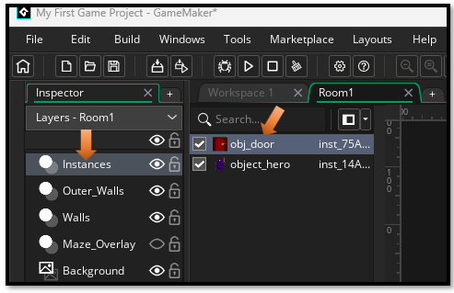
We should just have the Outer Walls left in the room
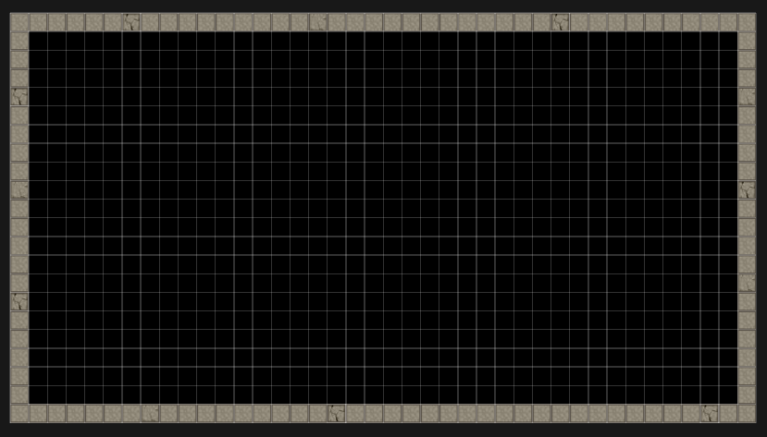

The Controller Enters the Room
Throw the Controller object into the room.
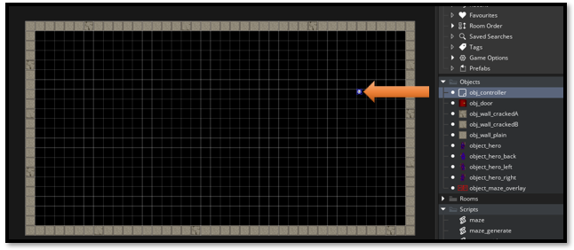

Test your Game

